Loan Consolidation Navigation Guide

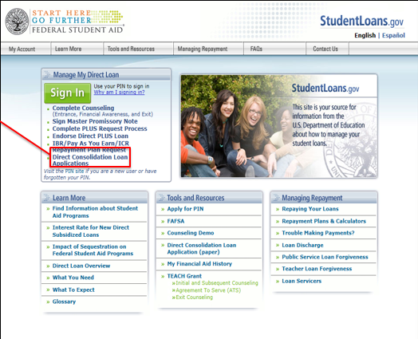
- Log on to your account at Studentloans.gov and select “Complete Direct Consolidation Loan Application and Promissory Note”. If this is your first visit, see the middle column at the bottom of the page and select “Apply for PIN.” You will need this to log in.
- On the following page a section called “Important Note” will appear suggesting you use a different website to apply. Do not do this. Read the remainder of the page and select “Start Application” at the bottom.
Step 1: Log on to Studentloans.gov.
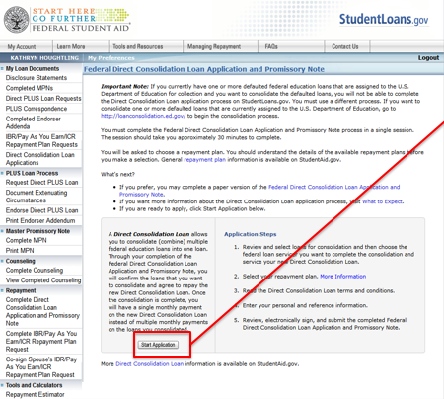
- You will now begin the application process. The first step is titled “Choose Loans and Servicer”. Select which loans you wish to consolidate. We suggest you consolidate all pre-populated loans. You also have the option to add any additional loans that you do not see in the list. A maximum of 30 loans will auto-fill, if you have more loans than that please add them manually. You can do this by clicking “Add Loans” at the bottom of the list of loans. This will open a pop up window where you can enter the information for additional loans. Be sure to add any Nursing or Health Professions loans you may have as these may not pre-fill on the form. Although private loans may not qualify for consolidation, add any private loans as these figures will be added to your debt-to-income (DTI) ratio and may reduce your expected monthly repayment amount.
Step 2: Click “Start Application.”
- After you have selected the loans you would like consolidated, you must choose what servicer (PHEAA, GLHEC, NelNet, SLMA/Navient) you would like to house your consolidated loans. If you are applying to take advantage of the Public Service Loan Forgiveness, select “Yes”. This will limit your servicer choices to Pennsylvania Higher Education Assistance Agency (PHEAA). Should you have any questions during application, contact the servicer you have selected. Their contact information is available on the last page.
- In this step, you also have the ability to delay the processing of your application if one of your loans is still in a grace period. If you choose to do this and the servicer determines no loans are in grace, they will begin processing your application. You have now completed the first section.
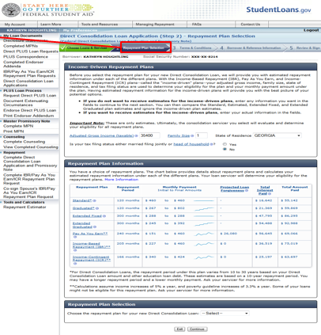
- The next step allows you to choose your preferred repayment plan. By entering the information in the “Income-Driven Repayment Plans” box, you will be able to see what the estimated monthly payments, total interest paid, and total payoff amounts will be for each plan. After looking these over, you can select the plan you are most interested in pursuing at the bottom of the page. If money is tight or if you have a past due loan select an Income Driven Repayment (IDR) plan such as Pay as You Earn (Pay-E) , Income Based (IBR) or Income Contingent (ICR) plan.
- After doing so, you will be directed to a page inquiring about spousal information. For convenience this step allows both you and your spouse to consolidate your respective loans. The new loan(s) will not be comingled and will remain separate from each other.
Step 6: Select your repayment plan.
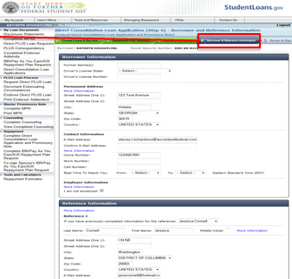
- At the bottom of this page, you will be able to link your Tax Return information to determine what your payments will actually be. Here you will simply need to click “Link to IRS” and fill out the information on the following page. When the information has been located you will be given an option to transfer the information. Select “Transfer Now.” Following this you will need to answer a few verifying questions about the tax information that was just transferred.
- ** If you have chosen to add your spouse’s loans, you will need them to now sign the request. They can either do this now, or log in at a later time using the Co-sign code provided. When your spouse logs in to sign the request they will need to fill out a section on their personal information as well.
- After these steps have been taken, you will be shown the terms and conditions page. Read these carefully before marking the checkbox saying that the terms and conditions have been read and will be agreed to.
- Upon doing this, you will be routed to a page asking for your personal information along with references for the loan application. If you have previously submitted reference information on another Studentloans.gov application, that information will appear in a dropdown menu to be selected. You are not required to use the same references, however. You may list new references. Do not use references that share your same address.
Step 11: Update your personal information.
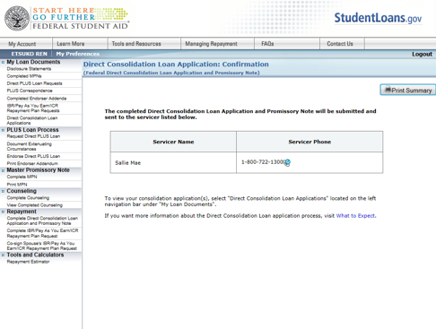
- When this has all been done, you will be able to review and sign the application electronically. This final page will show various information you have previously provided such as the loans you wish to consolidate, what servicer and repayment plan you have selected, and your personal information among other things. If everything looks good, electronically sign the application at the bottom of the page and click the “Sign and Submit” button.
Step 13: Receive confirmation.
- When this is done, you will receive a confirmation page and your application is complete!
- Should you need to review your application you can do so by logging into your Studentloans.gov account and look at your application under your loan documents. You will also be able to add any additional loans to your consolidation within 180 days of the first disbursement of your consolidation loan.
- If you move during the application process, contact your lender and update the contact information. See below. Many applications fail due to a change of address.

Servicer Contact Information
Servicer | Phone Number
Fed Loan Servicing/ Pennsylvania Higher Education Assistance Agency (PHEAA)  http://www.myfedloan.org | (717) 720-2110
Great Lakes Educational Loan Services (GLHEC)  https://www.mygreatlakes.org | (866) 348-0714
Nelnet (NelNet)  http://www.nelnet.com | (855) 554-0050
Sallie Mae / Navient (SLMA)  http://www.salliemae.com/federalloans | (317) 578-6176

