October 18, 2018

Address
Address
Address

Consolidation is a great solution and a fresh start.
No Cost! Consolidation is FREE! And YOU qualify!
Please apply online at https://studentloans.gov/ .

Choose an Income Driven Repayment plan to base any required payments upon your family size and income. Payments may not be required.
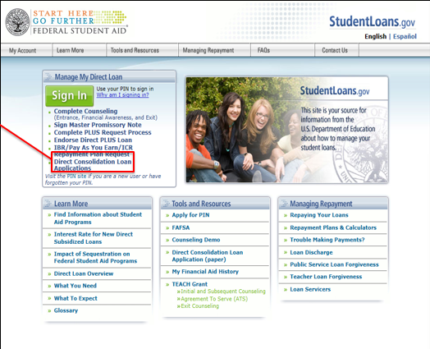
Take advantage of this.
You may qualify for the Pay-As-You Earn (Pay-E) repayment plan(s) to cap payments at 10% of your discretionary income

Let’s solve this student loan headache and get you a fresh start!
Regards,

Student Loan Servicing
sls2@finaid.wisc.edu

View your account online with school code R 7 at https://www.ecsi.net/ .
This is NOT your Great Lakes Higher Education or SLMA or Stafford loan - do not confuse us.
This Federal program will only take Federal (Perkins/Stafford/Direct/Nursing) Loans.
Loans we suggest you consolidate:

Type of Loan | Loan Amount | Servicer and Address
Direct Stafford Subsidized | $3,500.00 | Dept. of Ed/FedLoan Servicing, PO Box 69184, Harrisburg, PA 17106-9184, (800) 699-2908
Direct Stafford Unsubsidized | $2,000.00 | Dept. of Ed/FedLoan Servicing, PO Box 69184, Harrisburg, PA 17106-9184, (800) 699-2908
Perkins | $2,000.00 | Univ. of Wisconsin, 333 E Campus Mall 10501, Madison Wi 53715-1383, (608) 263-7100
Choose an item. | Click here to enter text. | Select One

